**Practical no.-**2

**Title:** Develop JavaScript to use decision making and looping statements.

**Roll No.:** **Batch-** A **Date of Performance:** 01/08/2023

**Code-**

**EVEN & ODD**

<html>

<head>

<title>Even & Odd</title>

</head>

<body>

<script type="text/javascript">

document.write("Even Numbers"+"<br>");

for (var i = 1; i <= 10; i++)

{

if(i%2==0)

{

document.write(i+"<br>");

}

}

document.write("<br>Odd Numbers"+"<br>");

for (var i = 1; i <= 10; i++)

{

if(i%2!=0)

{

document.write(i+"<br>");

}

}

</script>

</body>

</html>

**Output-**

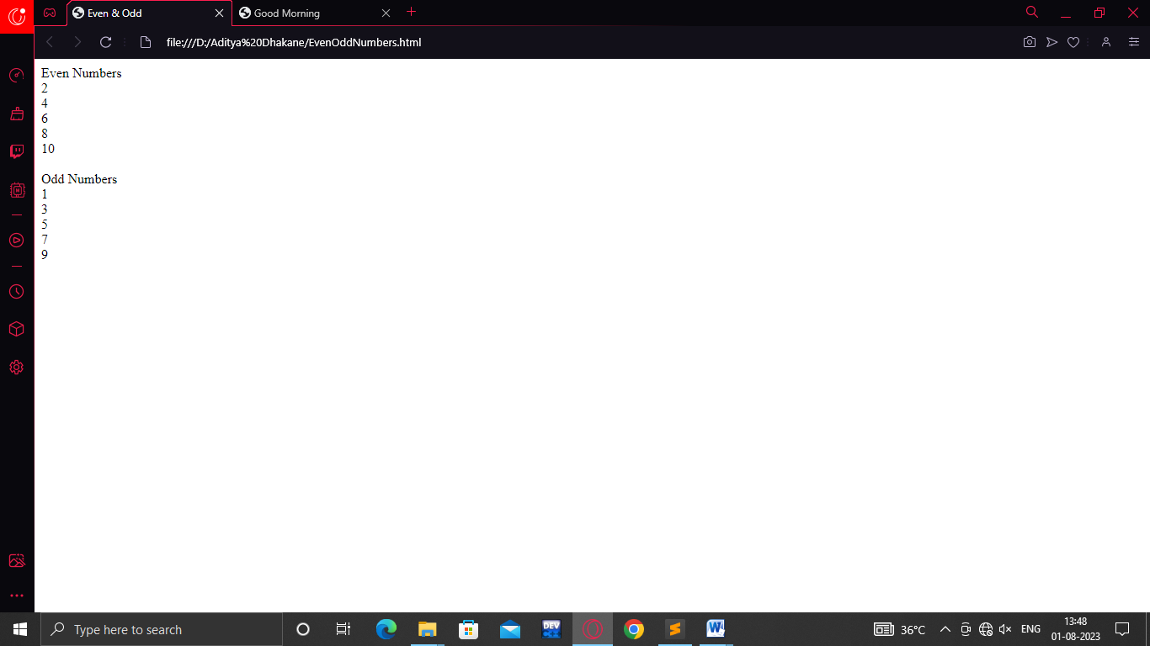

**Prime Numbers**

<html>

<head>

<title>Prime Numbers</title>

</head>

<body>

<h1 align="left">Prime Numbers</h1>

<hr>

<p

<label>Prime Numbers between 1 to 25</label></p>

<script type="text/javascript">

var count=0;

for (var i = 1; i <= 25; i++)

{

count=0;

for (var j = 1; j <= i; j++)

{

if(i%j==0)

{

count=count+1;

}

}

if(count==2)

{

document.write(i+"<br>");

}

}

</script>

</body>

</html>

**Output-**

